**PROJECT REPORT TEMPLATE**

**1 INTRODUCTION**

**1.1 Overview**

India is theworld’s third largest consumer of electricity. The national electric producer and national electric grid in the India as an installed capacity of 370.106GW as of 31 March 2020. Renewable power plant, which also include large hydroelectric plants, constitute 35.86% of India’s total installed capacity. During the fiscal year (FY) 2019-20, the total electricity generation in the country was 1,598TWh, of which 1,383.5TWh was generated by utilities. The gross electricity consumption per capita in FY2019 was 1,208kWh.

The dataset is exhaustive in its demonstration of energy consumption state wise.

Analyzing Electricity consumption in India from January 2019 till 5th December 2020. This dataset contains a record of electricity consumption in each state of India, here we are going to Analyse state wise, region wise, and Overall electricity consumption in India.

**1.2 Purpose:**

Industrial and Commerical activity account for more than half of India’s annual power use. Homes account for a fourth, while agriculture has accounted for over a sixth in recent years.

**2. PROBLEM DEFINITION & DESGIN THINKING**

**2.1 Empathy map**

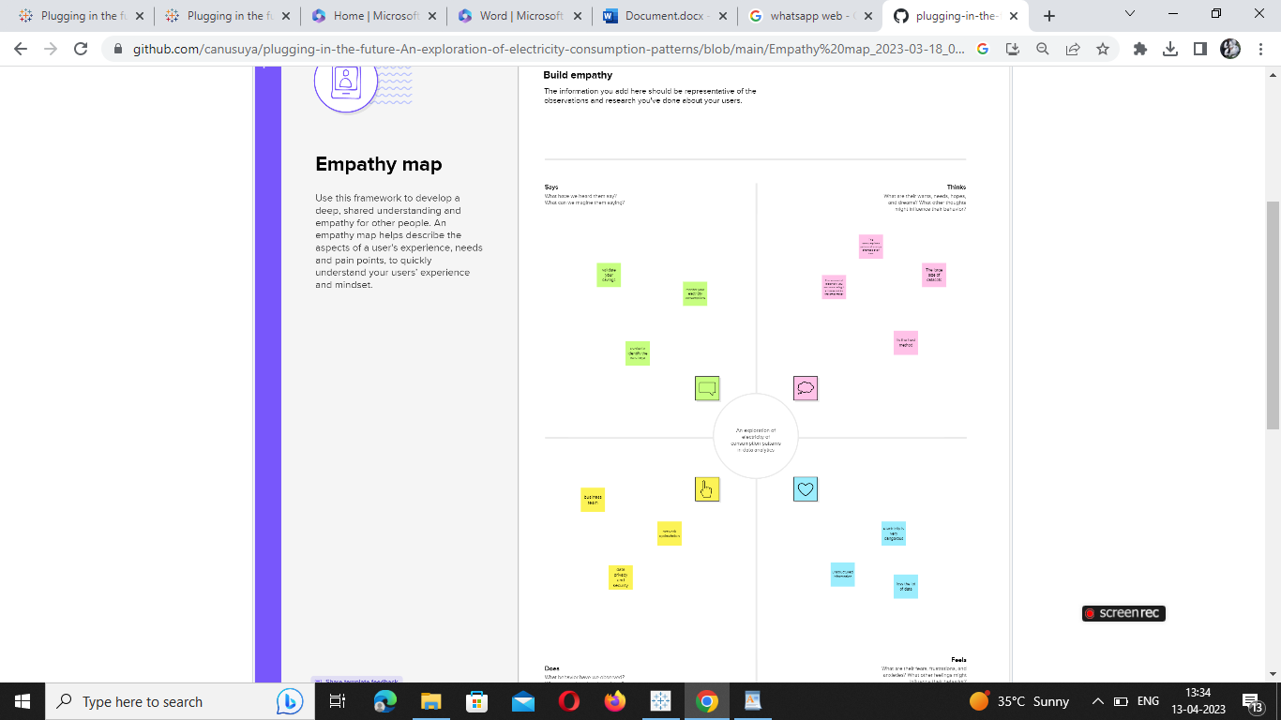

**2.2 Brainstorming & Ideation Map**

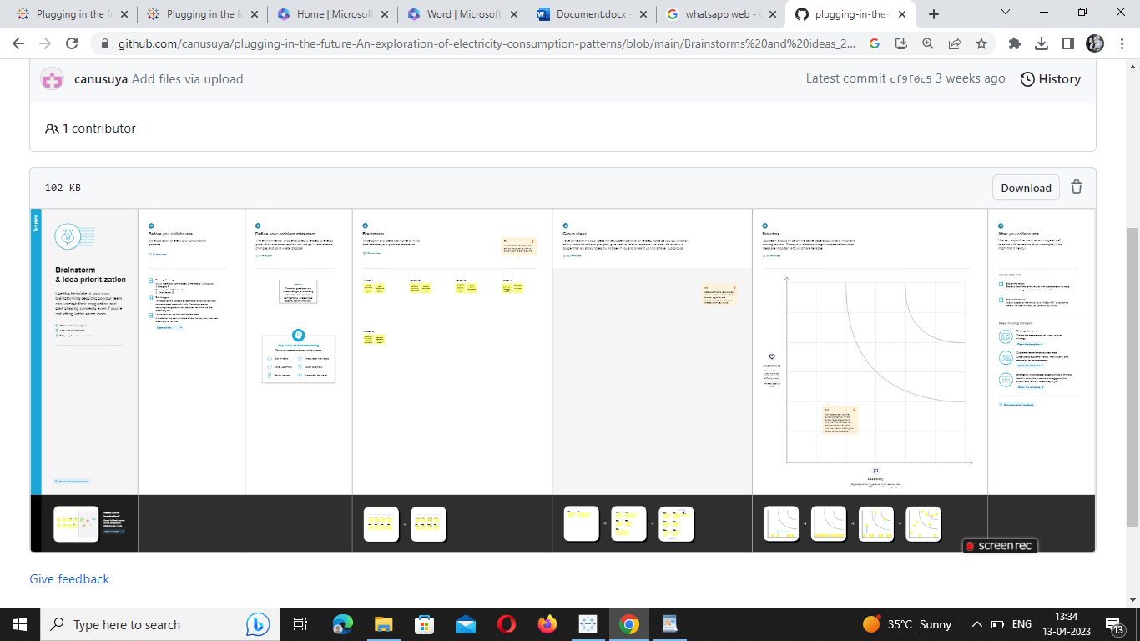

**3.RESULT:**

**VISULIZATION, DASHBOARD AND STORY**

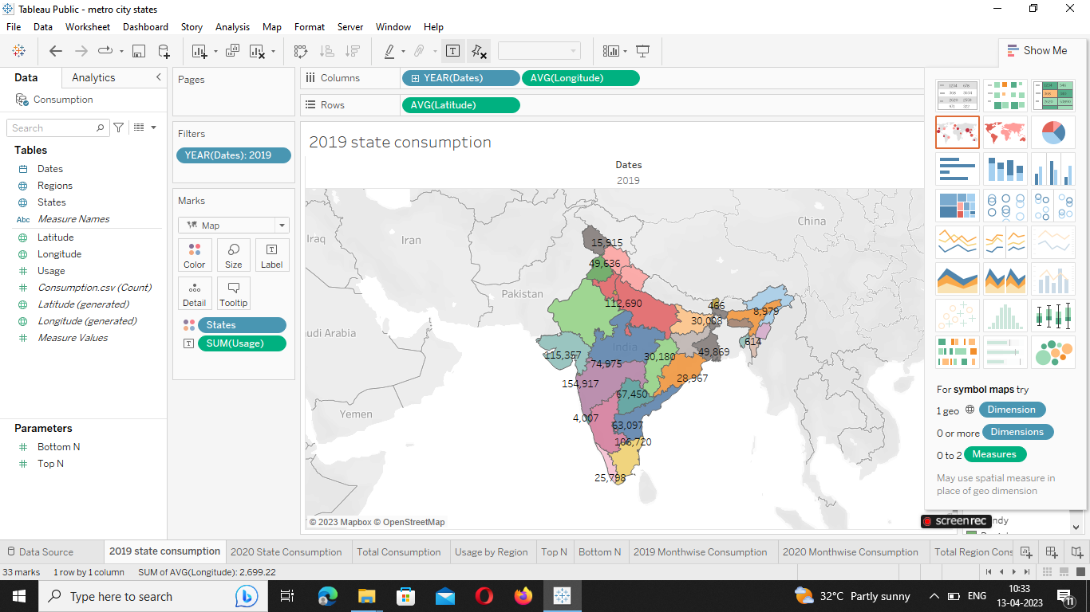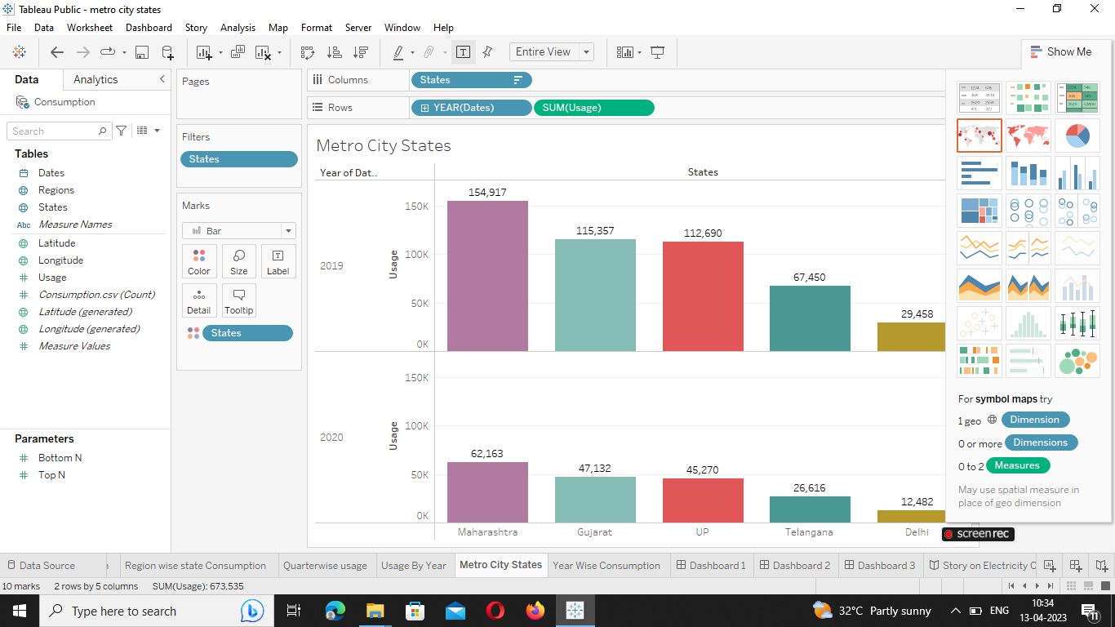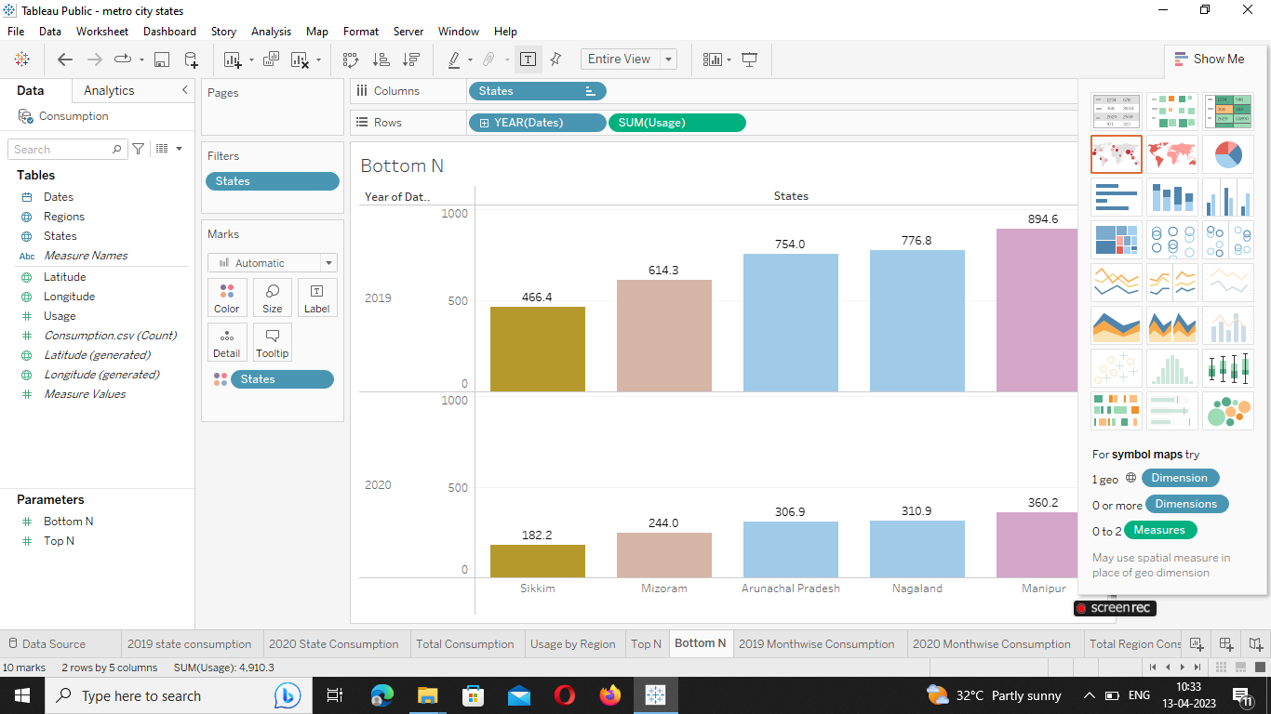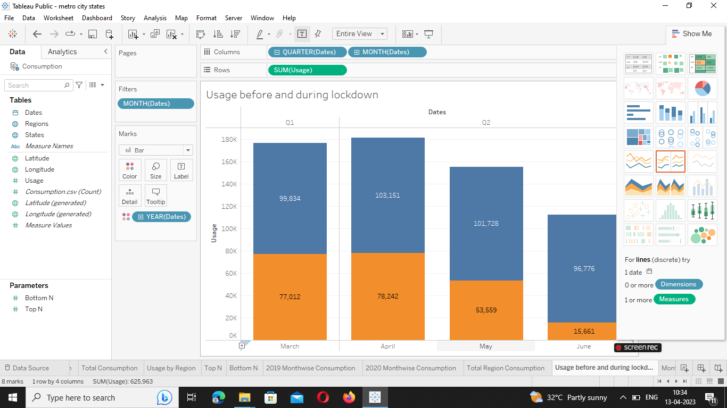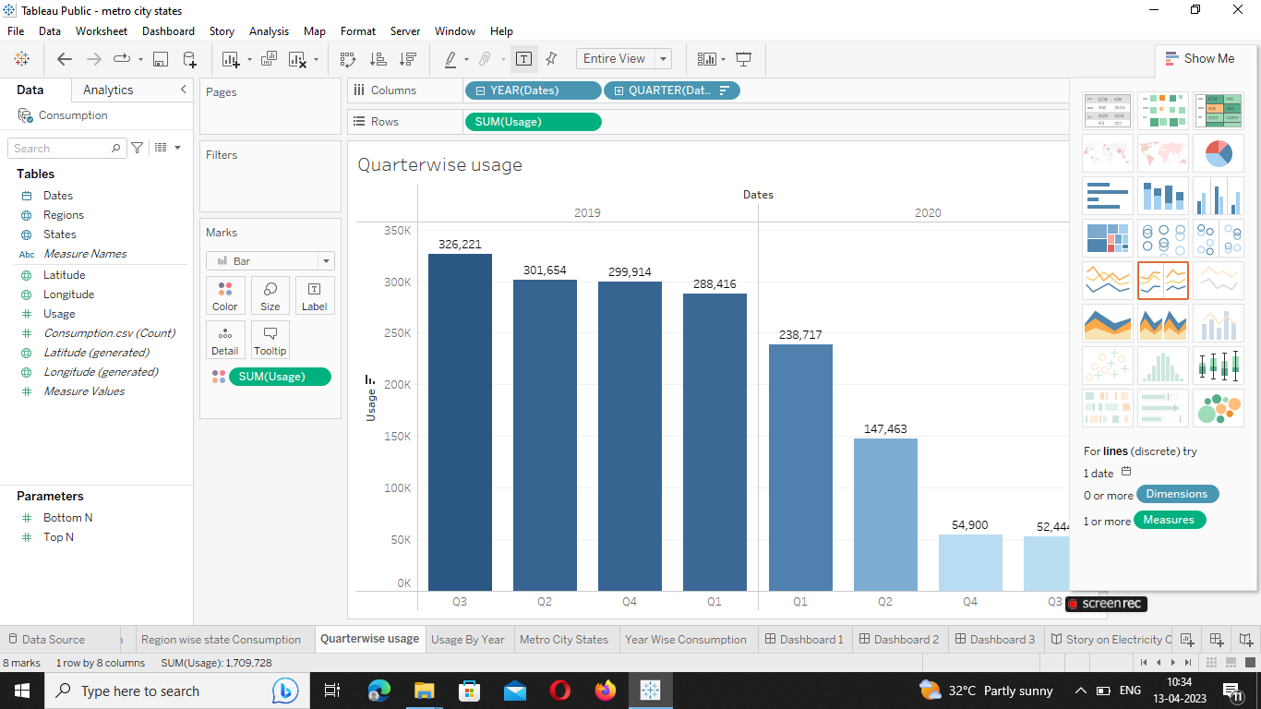

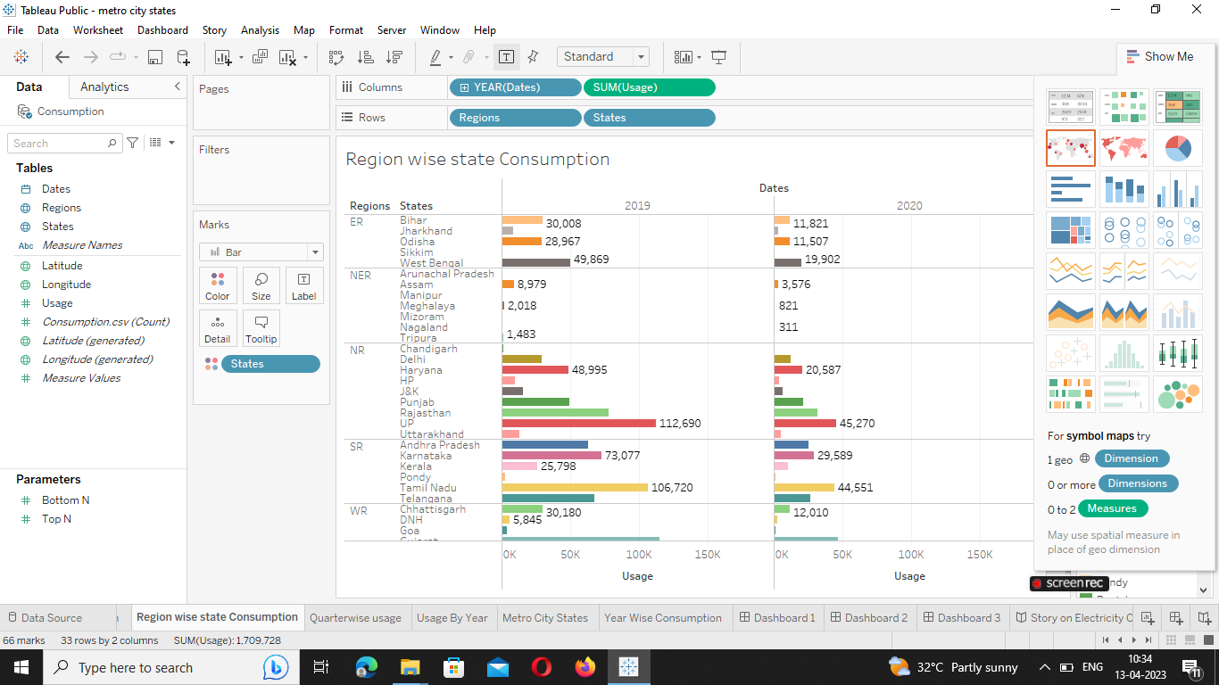

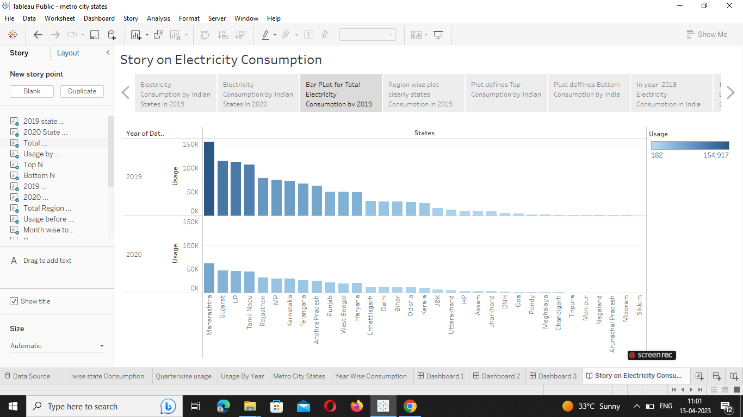

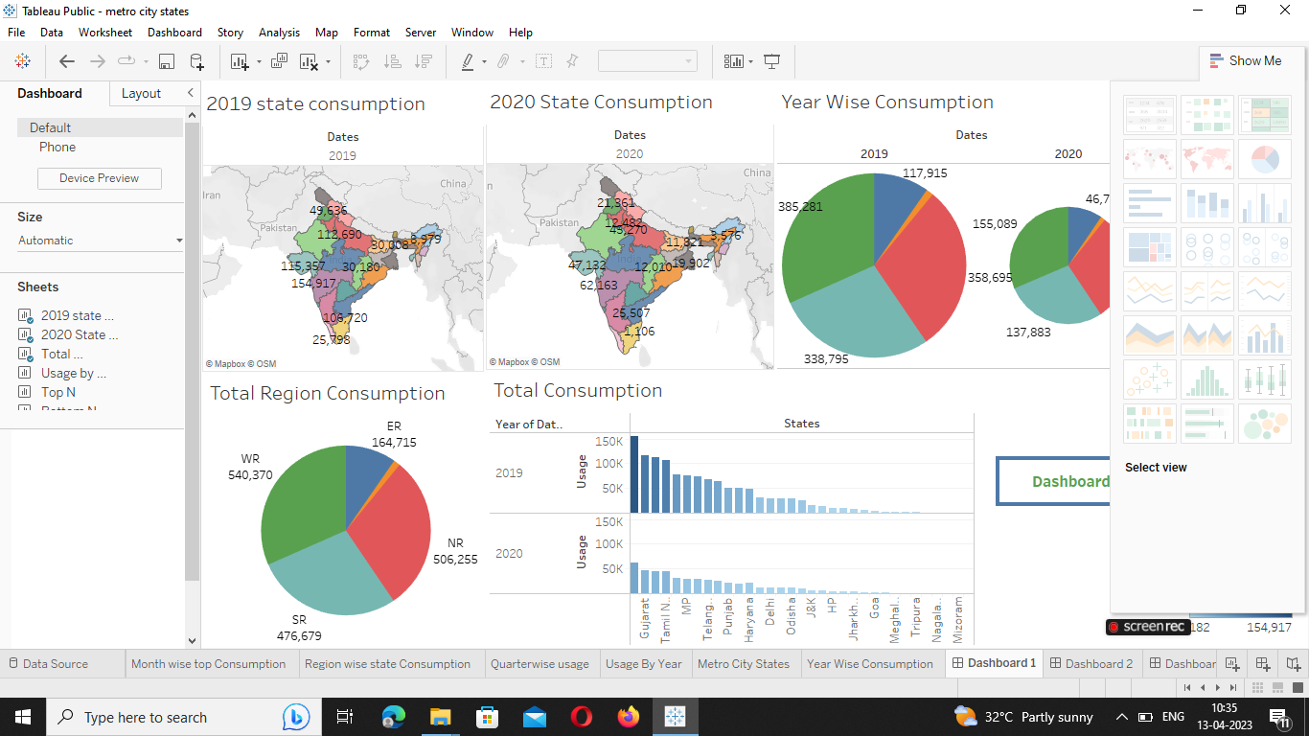

**4. I) ADVANTAGE**

* Annual Electricity consumption per capita serves as an important measure of a country’s electric power development.
* Generally speaking, Electricity consumption grows faster.
* When the industrialization process develops quickly and goes down rapidly.

**II) DISADVANTAGE**

* Carbon dioxide is a greenhouse gas that causes Earth’s temperature to rise.
* Requires SQL knowledge.
* Not a comprehensive solution.

**5. APPLICATION**

* In my team completed the work for many consumptions in region wise and quarter wise etc.
* And they arecalculating dataset using by the 2019 and 2020 consumptions in India by states wise reading.

**6. Conclusion**

* Electric energy consumption is the form of energy consumption that uses electrical energy.
* Electric energy consumption is the actual energy demand made on existing electricity.
* Supply for transportation, residential, industrial, commercial, and other miscellaneous purposes.

**SOURCE CODE FOR MY PROJECT:**

<!DOCTYPE html>

<html lang="en">

<head>

<meta charset="utf-8">

<meta content="width=device-width, initial-scale=1.0" name="viewport">

<title>Electricity Consumption Analysis </title>

<meta content="" name="description">

<meta content="" name="keywords">

<!-- Favicons -->

<link href="assets/img/favicon.png" rel="icon">

<link href="assets/img/apple-touch-icon.png" rel="apple-touch-icon">

<!-- Google Fonts -->

<link href="https://fonts.googleapis.com/css?family=Open+Sans:300,300i,400,400i,600,600i,700,700i|Jost:300,300i,400,400i,500,500i,600,600i,700,700i|Poppins:300,300i,400,400i,500,500i,600,600i,700,700i" rel="stylesheet">

<!-- Vendor CSS Files -->

<link href="assets/vendor/aos/aos.css" rel="stylesheet">

<link href="assets/vendor/bootstrap/css/bootstrap.min.css" rel="stylesheet">

<link href="assets/vendor/bootstrap-icons/bootstrap-icons.css" rel="stylesheet">

<link href="assets/vendor/boxicons/css/boxicons.min.css" rel="stylesheet">

<link href="assets/vendor/glightbox/css/glightbox.min.css" rel="stylesheet">

<link href="assets/vendor/remixicon/remixicon.css" rel="stylesheet">

<link href="assets/vendor/swiper/swiper-bundle.min.css" rel="stylesheet">

<!-- Template Main CSS File -->

<link href="assets/css/style.css" rel="stylesheet">

<!-- =======================================================

* Template Name: Arsha

* Updated: Mar 10 2023 with Bootstrap v5.2.3

* Template URL: <https://bootstrapmade.com/arsha-free-bootstrap-html-template-corporate/>

* Author: BootstrapMade.com

* License: <https://bootstrapmade.com/license/>

======================================================== -->

</head>

<body>

<!-- ======= Header ======= -->

<header id="header" class="fixed-top ">

<div class="container d-flex align-items-center">

<h1 class="logo "><img src="https://encrypted-tbn0.gstatic.com/images?q=tbn:ANd9GcQLlEZBnzzvZRQG89AqRNE8QeRb0lOfgR1pNg&usqp=CAU" ></h1>

<!-- Uncomment below if you prefer to use an image logo -->

<!-- <a href="index.html" class="logo me-auto"><img src="assets/img/logo.png" alt="" class="img-fluid"></a>-->

<nav id="navbar" class="navbar">

<ul>

<li><a class="nav-link scrollto active" href="#hero">Home</a></li>

<li><a class="nav-link scrollto" href="#about">Dashboard</a></li>

<li><a class="nav-link scrollto" href="#services">Story</a></li>

<li><a class="nav-link scrollto" href="#portfolio">Visualization</a></li>

<li><a class="nav-link scrollto" href="#team">Conclusion</a></li>

<ul>

<i class="bi bi-list mobile-nav-toggle"></i>

</nav><!-- .navbar -->

</div>

</header><!-- End Header -->

<!-- ======= Hero Section ======= -->

<section id="hero" class="d-flex align-items-center">

<div class="container d-flex flex-column align-items-center justify-content-center" data-aos="fade-up">

<br/>

<br/>

<br/>

<h1> Analysis on Electricity

Consumption in India</h1>

<h2>India is thr third largest producer of electricity in the world. During the fiscal year (FY) 2019-2020,

the total electricity generation in the country was 1,598 TWh, of which 1,383.5TWh generated by utilities.

The gross electricity connsumption per capita in FY2019 was 1,208 kWh.</h2>

<a href="#about" class="btn-get-started scrollto">Get Started</a>

<img src="https://1.bp.blogspot.com/-ln_q-Jshzig/XHtXb4WIguI/AAAAAAAAA5s/BhNYwuR8Ro4NmLkpNEfpjIiu85NOh8-JgCKgBGAs/s1600/dpl-power-to-home.png" class="img-fluid hero-img" alt="" data-aos="zoom-in" data-aos-delay="150">

</div>

</section>

<!-- End Hero -->

<main id="main">

<section id="about" class="about">

<div class="container">

<div class='tableauPlaceholder' id='viz1681227253419' style='position: relative'>

<noscript><a href='#'><img alt='Dashboard 1 ' src='https:&#47;&#47;public.tableau.com&#47;static&#47;images&#47;Pl&#47;PlugginginthefutureAnExplorationofElectricityConsumptionspatterrns&#47;Dashboard1&#47;1_rss.png' style='border: none' /></a></noscript>

<object class='tableauViz' style='display:none;'>

<param name='host_url' value='https%3A%2F%2Fpublic.tableau.com%2F' />

<param name='embed_code_version' value='3' />

<param name='site_root' value='' />

<param name='name' value='PlugginginthefutureAnExplorationofElectricityConsumptionspatterrns&#47;Dashboard1' />

<param name='tabs' value='no' />

<param name='toolbar' value='yes' />

<param name='static_image' value='https:&#47;&#47;public.tableau.com&#47;static&#47;images&#47;Pl&#47;PlugginginthefutureAnExplorationofElectricityConsumptionspatterrns&#47;Dashboard1&#47;1.png' />

<param name='animate_transition' value='yes' />

<param name='display_static_image' value='yes' />

<param name='display_spinner' value='yes' />

<param name='display_overlay' value='yes' />

<param name='display_count' value='yes' />

<param name='language' value='en-US' />

<param name='filter' value='publish=yes' />

<param name='showShareOptions' value='false' />

</object>

</div> <script type='text/javascript'>

var divElement = document.getElementById('viz1681227253419');

var vizElement = divElement.getElementsByTagName('object')[0];

if ( divElement.offsetWidth > 800 ) {

vizElement.style.width='100%';

vizElement.style.height=(divElement.offsetWidth*0.75)+'px';

} else if ( divElement.offsetWidth > 500 ) {

vizElement.style.width='100%';

vizElement.style.height=(divElement.offsetWidth*0.75)+'px';

} else { vizElement.style.width='100%';

vizElement.style.height='1827px';

}

var scriptElement = document.createElement('script');

scriptElement.src = '<https://public.tableau.com/javascripts/api/viz_v1.js>';

vizElement.parentNode.insertBefore(scriptElement, vizElement);

</script>

<!--======= About Section=======-->

<div class="row no-gutters">

<div class="content col-xl-5 d-flex align-items-stretch" data-aos="fade-right">

<div class="content">

<h3>History</h3>

<p> India began using grid managment on a regional basis in the 1960s. Individual State grids were interconnected to form

5 regional grids covering mainland India, the Northern, Eastern, Westerrn, North Eastern and Southern Grids.

These regional links were established to enable transmission of surplus electricity between states in each region.

</p>

<p>The first interconnection of regional grids was established in October 1991 when the North Eastern

and Eastern grids were interconnected.The Western Grid was interconnected with these grids in March 2003. The Northern

grid was also interconnceted in August 2006, forming a Central Grid and operating at one frequency.

The Southern Grid, was synchronously interconnected to the Central Grid on 31 December 2013 with the Commissioninng of the 765kV

Raichur-Solapur transmission line, establishing the National Grid</p>

</div>

</div>

<div class="col-xl-7 d-flex align-items-stretch" data-aos="fade-left">

<div class="icon-boxes d-flex flex-column justify-content-center">

<div class="row">

<div class="col-md-3 " data-aos="fade-up" data-aos-delay="80">

<img src="assets\img\gen.jpg" class="" alt="" width="" height="">

</div>

</div>

</div>

<!-- End .content-->

</div>

</div>

</div>

</section>

<!--End About Section-->

<!-- ======= Clients Section ======= -->

<section id="clients" class="clients">

<div class="container" data-aos="zoom-in">

<div class="row" >

<div class="col-lg-2 col-md-4 col-6 d-flex align-items-center justify-content-center">

<img src="assets/img/clients/client-1.png" class="img-fluid" alt="">

</div>

<div class="col-lg-2 col-md-4 col-6 d-flex align-items-center justify-content-center">

<img src="assets/img/clients/client-2.png" class="img-fluid" alt="">

</div>

<div class="col-lg-2 col-md-4 col-6 d-flex align-items-center justify-content-center">

<img src="assets/img/clients/client-3.png" class="img-fluid" alt="">

</div>

<div class="col-lg-2 col-md-4 col-6 d-flex align-items-center justify-content-center">

<img src="assets/img/clients/client-4.png" class="img-fluid" alt="">

</div>

<div class="col-lg-2 col-md-4 col-6 d-flex align-items-center justify-content-center">

<img src="assets/img/clients/client-5.png" class="img-fluid" alt="">

</div>

<div class="col-lg-2 col-md-4 col-6 d-flex align-items-center justify-content-center">

<img src="assets/img/clients/client-6.png" class="img-fluid" alt="">

</div>

</div>

</div>

</section>

<!-- End Clients Section -->

<!--=======Service Section=======-->

<section id="Service" class="Service">

<div class="container" data-aos="fade-up">

<div class='tableauPlaceholder' id='viz1681232325605' style='position: relative'><noscript><a href='#'><img alt='Story on Electricity Consumption ' src='https:&#47;&#47;public.tableau.com&#47;static&#47;images&#47;Pl&#47;PlugginginthefutureAnExplorationofElectricityConsumptionspatterrnsstory&#47;StoryonElectricityConsumption&#47;1_rss.png' style='border: none' /></a></noscript>

<object class='tableauViz' style='display:none;'>

<param name='host_url' value='https%3A%2F%2Fpublic.tableau.com%2F' />

<param name='embed_code_version' value='3' />

<param name='site_root' value='' />

<param name='name' value='PlugginginthefutureAnExplorationofElectricityConsumptionspatterrnsstory&#47;StoryonElectricityConsumption' />

<param name='tabs' value='no' />

<param name='toolbar' value='yes' />

<param name='static_image' value='https:&#47;&#47;public.tableau.com&#47;static&#47;images&#47;Pl&#47;PlugginginthefutureAnExplorationofElectricityConsumptionspatterrnsstory&#47;StoryonElectricityConsumption&#47;1.png' />

<param name='animate_transition' value='yes' />

<param name='display_static_image' value='yes' />

<param name='display_spinner' value='yes' />

<param name='display_overlay' value='yes' />

<param name='display_count' value='yes' />

<param name='language' value='en-US' />

<param name='filter' value='publish=yes' />

<param name='showSareOptions' value='false' />

</object></div> <script type='text/javascript'>

var divElement = document.getElementById('viz1681232325605');

var vizElement = divElement.getElementsByTagName('object')[0];

vizElement.style.width='100%';

vizElement.style.height=(divElement.offsetWidth*0.75)+'px';

var scriptElement = document.createElement('script');

scriptElement.src = '<https://public.tableau.com/javascripts/api/viz_v1.js>';

vizElement.parentNode.insertBefore(scriptElement, vizElement);

</script>

</div>

</section>

<!-- End Services Section -->

<!-- ======= Cta Section ======= -->

<!-- End Cta Section -->

<!-- ======= Portfolio Section ======= -->

<section id="portfolio" class="portfolio">

<div class="container" data-aos="fade-up">

<div class="section-title">

<h2>Visualization</h2>

</div>

<div class="row portfolio-container" >

<div class="col-lg-4 col-md-6 portfolio-item filter-app">

<div class="portfolio-img">

<img src="assets/img/portfolio/p1.jpg" class="img-fluid" alt="">

<div class="portfolio-info">

<h4>Image 1</h4>

<a href="assets/img/portfolio/p1.jpg" data-gallery="portfolioGallery" class="portfolio-lightbox preview-link" title="Image 1"><i class="bx bx-plus"></i></a>

<a href="portfolio-details.html" class="details-link" title="More Details"><i class="bx bx-link"></i></a>

</div>

</div>

<div class="col-lg-4 col-md-6 portfolio-item filter-web">

<div class="portfolio-img"><img src="assets/img/portfolio/p2.jpg" class="img-fluid" alt="">

<div class="portfolio-info">

<h4>Image 2</h4>

<a href="assets/img/portfolio/p2.jpg" data-gallery="portfolioGallery" class="portfolio-lightbox preview-link" title="Image 2"><i class="bx bx-plus"></i></a>

<a href="portfolio-details.html" class="details-link" title="More Details"><i class="bx bx-link"></i></a>

</div>

</div>

<div class="col-lg-4 col-md-6 portfolio-item filter-app">

<div class="portfolio-img"><img src="assets/img/portfolio/p3.jpg" class="img-fluid" alt=""></div>

<div class="portfolio-info">

<h4>Image 3</h4>

<a href="assets/img/portfolio/p3.jpg" data-gallery="portfolioGallery" class="portfolio-lightbox preview-link" title="App 2"><i class="bx bx-plus"></i></a>

<a href="portfolio-details.html" class="details-link" title="More Details"><i class="bx bx-link"></i></a>

</div>

</div>

<div class="col-lg-4 col-md-6 portfolio-item filter-card">

<div class="portfolio-img"><img src="assets/img/portfolio/p4.jpg" class="img-fluid" alt=""></div>

<div class="portfolio-info">

<h4>Image 4</h4>

<p>Card</p>

<a href="assets/img/portfolio/p4.jpg" data-gallery="portfolioGallery" class="portfolio-lightbox preview-link" title="Card 2"><i class="bx bx-plus"></i></a>

<a href="portfolio-details.html" class="details-link" title="More Details"><i class="bx bx-link"></i></a>

</div>

</div>

<div class="col-lg-4 col-md-6 portfolio-item filter-web">

<div class="portfolio-img"><img src="assets/img/portfolio/p5.jpg" class="img-fluid" alt=""></div>

<div class="portfolio-info">

<h4>Image 5</h4>

<p>Web</p>

<a href="assets/img/portfolio/p5.jpg" data-gallery="portfolioGallery" class="portfolio-lightbox preview-link" title="Web 2"><i class="bx bx-plus"></i></a>

<a href="portfolio-details.html" class="details-link" title="More Details"><i class="bx bx-link"></i></a>

</div>

</div>

<div class="col-lg-4 col-md-6 portfolio-item filter-app">

<div class="portfolio-img"><img src="assets/img/portfolio/p6.jpg" class="img-fluid" alt=""></div>

<div class="portfolio-info">

<h4>Image 6</h4>

<p>App</p>

<a href="assets/img/portfolio/p6.jpg" data-gallery="portfolioGallery" class="portfolio-lightbox preview-link" title="App 3"><i class="bx bx-plus"></i></a>

<a href="portfolio-details.html" class="details-link" title="More Details"><i class="bx bx-link"></i></a>

</div>

</div>

</div>

</div>

</div>

</section><!-- End Portfolio Section -->

<section id="features" class="features" data-aos="fade-up">

<div class="container">

<div class="section-title">

<h2>Conclusion</h2>

</div>

<div class="row content">

<div class="col-md-5" data-aos="fade-right" data-aos-delay="100">

<img src="assest/img/img1.jpg" class="img-fluid" alt="">

</div>

<div class="col-md-7 pt-4" data-aos="fade-right" data-aos-delay="100">

<h3>Electricity Consumption States.</h3>

<ul>

<li><i class="bi bi-check"></i>Maharashtra is the highest Electricity consumption user of India</li>

<li><i class="bi bi-check"></i> Gujarat is the second highest electricity consumption user of India</li>

<li><i class="bi bi-check"></i>Sikkim is the lowest Electricity Consumption user of India

</li>

</ul>

</div>

</div>

<div class="row content">

<div class="col-md-5 order-md-2" data-aos="fade-left">

<img src="assest\img\img2.jpg" class="img-fluid" alt="">

</div>

<div class="col-md-5 pt-5 order-1 order-md-1" data-aos="fade-right">

<h3>Electricity consumption before and durinng Lockdown in India</h3>

<p class="">Electricity Consumption was more in 2019 in month of march-june before lockdown</p>

<p class=""> Electricity Consumption was less in 2020 in month of march-june durinng the lockdown</p>

</div>

</div>

<div class="row content">

<img src="assets/img/img3.jpg" class="img-fluid" alt="">

</div>

<div class="col-md-7" data-aos="fade-left">

<h3> Electricity CConsumption In Quaters</h3>

<ul>

<li><i class="bi bi-check"></i> Electricity Consumption in 2019 for Quarter 3 was Highest.</li>

<li><i class="bi bi-check"></i>Electricity Consumption in 2019 for Quarter 1 was Lowest. </li>

<li><i class="bi bi-check"></i> Electricity Consumption in 2020 for Quarter 3 was lowest.</li>

<li><i class="bi bi-check"></i>Electricity Consumption in 2020 for Qarter 1 was Highest.</li>

</ul>

</div>

</div>

<div class="row content">

<div class="col-md-5 order-1 order-md-2" data-aos="fade-left">

<img src="assets/img/img5.jpg" class="img fluid" alt="">

</div>

<div class="col-md-7 pt-5 order-2 order-md-1" data-aos="fade-right">

<h3> Electricity Consumption in Regions</h3>

<ul>

<li><i class="bi bi-check"></i>Total Electricity consumption in Western Region is Highest.</li>

<li><i class="bi bi-check"></i>Total Electricity consumption in North Eastern Region is Lowest.</li>

<li><i class="bi bi-check">Electricity consumption in 2020 for Quarter 3 was Lowest.</i></li>

<li><i class="bi bi-check">Electricity Consumption in 2020 for Quarter 1 was Highest.</i></li>

</ul>

</div>

</div>

</section>

<!-- ======= Contact Section ======= -->

<section id="contact" class="contact">

<div class="container" data-aos="fade-up">

<div class="section-title">

<h2>Contact</h2>

</div>

<div class="row">

<div class="col-lg-5 d-flex align-items-stretch">

<div class="info">

<div class="address">

<i class="bi bi-geo-alt"></i>

<h4>Location:</h4>

<p>Immaculate college for women cuddalore,Chinnakangannakuppam</p>

</div>

<div class="email">

<i class="bi bi-envelope"></i>

<h4>Email:</h4>

[<p>canusuya2612@gmail.com</p](mailto:<p>canusuya2612@gmail.com</p)>

</div>

<div class="phone">

<i class="bi bi-phone"></i>

<h4>Call:</h4>

<p>+1 5589 55488 55s</p>

</div>

<iframe src="https://www.google.com/maps/embed?pb=!1m14!1m8!1m3!1d12097.433213460943!2d-74.0062269!3d40.7101282!3m2!1i1024!2i768!4f13.1!3m3!1m2!1s0x0%3A0xb89d1fe6bc499443!2sDowntown+Conference+Center!5e0!3m2!1smk!2sbg!4v1539943755621" frameborder="0" style="border:0; width: 100%; height: 290px;" allowfullscreen></iframe>

</div>

</div>

<div class="col-lg-7 mt-5 mt-lg-0 d-flex align-items-stretch">

<form action="forms/contact.php" method="post" role="form" class="php-email-form">

<div class="row">

<div class="form-group col-md-6">

<label for="name">Your Name</label>

<input type="text" name="name" class="form-control" id="name" required>

</div>

<div class="form-group col-md-6">

<label for="name">Your Email</label>

<input type="email" class="form-control" name="email" id="email" required>

</div>

</div>

<div class="form-group">

<label for="name">Subject</label>

<input type="text" class="form-control" name="subject" id="subject" required>

</div>

<div class="form-group">

<label for="name">Message</label>

<textarea class="form-control" name="message" rows="10" required></textarea>

</div>

<div class="my-3">

<div class="loading">Loading</div>

<div class="error-message"></div>

<div class="sent-message">Your message has been sent. Thank you!</div>

</div>

<div class="text-center"><button type="submit">Send Message</button></div>

</form>

</div>

</div>

</div>

</section><!-- End Contact Section -->

</main><!-- End #main -->

<!-- ======= Footer ======= -->

<footer id="footer">

<div class="container d-md-flex py-4">

<div class="me-md-auto text-mcenter text-md-start">

<div class="copyright">

&copy; Copyright <strong><span>Smartbridge</span></strong>. All Rights Reserved

</div>

<div class="credits">

<!-- All the links in the footer should remain intact. -->

<!-- You can delete the links only if you purchased the pro version. -->

<!-- Licensing information: <https://bootstrapmade.com/license/> -->

<!-- Purchase the pro version with working PHP/AJAX contact form: <https://bootstrapmade.com/arsha-free-bootstrap-html-template-corporate/> -->

Designed by <a href="https://bootstrapmade.com/">Anusuya.c</a>

</div>

</div>

</div>

</div>

</footer><!-- End Footer -->

<div id="preloader"></div>

<a href="#" class="back-to-top d-flex align-items-center justify-content-center"><i class="bi bi-arrow-up-short"></i></a>

<!-- Vendor JS Files -->

<script src="assets/vendor/aos/aos.js"></script>

<script src="assets/vendor/bootstrap/js/bootstrap.bundle.min.js"></script>

<script src="assets/vendor/glightbox/js/glightbox.min.js"></script>

<script src="assets/vendor/isotope-layout/isotope.pkgd.min.js"></script>

<script src="assets/vendor/swiper/swiper-bundle.min.js"></script>

<script src="assets/vendor/waypoints/noframework.waypoints.js"></script>

<script src="assets/vendor/php-email-form/validate.js"></script>

<!-- Template Main JS File -->

<script src="assets/js/main.js"></script>

</body>

</html>